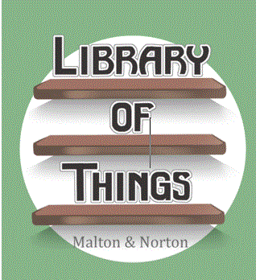 | LoTMN Volunteer Timesheet

Please help us to promote recognition of the amazing contribution that volunteers make to Library of Things Malton & Norton by registering your hours with us. We can often make particular use of recording volunteer hours in applications for funding new work and in helping to evidence what we have achieved as part of current funding that we receive. The time you submit also keeps your record active and enables us to send you invites to events, get-togethers and volunteers’ e-newsletter. Thank you for all the time you give. We appreciate your support.

Please complete the table below and return it to us each month at libraryofthingmn@gmail.com with your name and a brief description of the types of activities you have undertaken.

Name:
Email:

Date | Activities undertaken | No. Hours
 | Grand Total

